**PLANT DAYLIGHT INTENSITY , SOIL MOISTURE & PH DETECTOR**

by

SOHAM DESHPANDE 18BLC1063

AAKASH AGGARWAL 18BLC1060

AANACHAL SARASWAT 18BLC1018

SHREYA MAHNA 18BLC1051

NAMAN SHARMA 18BLC1011

A project report submitted to

**PROF. SOFANA REKA**

**SCHOOL OF ELECTRONICS ENGINEERING**

in partial fulfilment of the requirements for the course of

**ECM1003 – CYBER PHYSICAL SYSTEMS**

in

**B.Tech. ELECTRONICS AND COMPUTER ENGINEERING**



**VIT UNIVERSITY, CHENNAI**

**Vandalur-Kelambakkam Road**

**Chennai – 600127**

**NOVEMBER 2019**

**BONAFIDE CERTIFICATE**

This is to certify that this project report entitled “**PLANT DAYLIGHT INTENSITY ,SOIL MOISTURE & PH DETECTOR “** is a bonafide work of**,** **SOHAM DESHPANDE (18BLC1063),AAKASH AGGARWAL (18BLC1060),**

**AANACHAL SARASWAT (18BLC1018),SHREYA MAHNA (18BLC1051),NAMAN SHARMA (18BLC1011)**

who carried out the project work under my supervision and guidance.

**Prof. Sofana Reka**

**School of Electronics Engineering (SENSE),**

**VIT University, Chennai**

**Chennai – 600 127.**

u

**PLANT DAYLIGHT INTENSITY ,SOIL MOISTURE & PH DETECTOR**

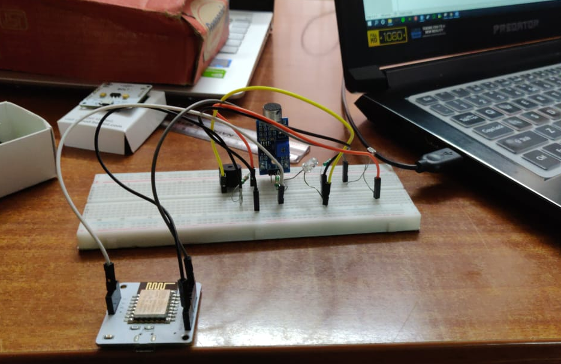

CONTENTS

1. Iot BOLT Device
2. Specifications of the Bolt Device
3. Controlling LED over Bolt Cloud
4. Controlling LED intensity using Bolt Cloud
5. Room Light Monitoring Project

Introduction

Iot BOLT Device

Bolt device is an another Arduino having Wi-Fi module with cloud computation. Bolt is an IoT platform to easily and quickly build products and services. Bolt comes with a WiFi/GSM chip and a cloud platform which helps you connect your devices and sensors to the Internet.

With Bolt Cloud you can control and monitor them over the internet, create personalised dashboards to visualise the data, monitor the device health, run machine learning algorithms and lot more. Build scalable IoT systems in just a days time.

BOLT is an Internet of Things platform Hardware+Software that enables user to build IoT products and projects. Using BOLT, users can control and monitor devices from any part of the world.

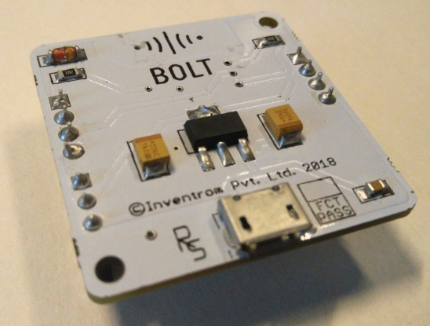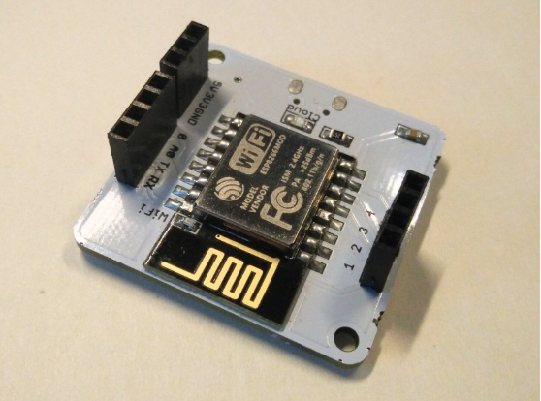

Bolt IoT is an integrated IoT platform that offers you with a WiFi Chip to connect your actuators and sensors to the Internet. You can configure such a system over the Bolt Cloud to receive, store and visualise the data over graphs. You can also connect actuators such as motors, light bulb and control them over the Internet. They also offer APIs to fetch data and control the devices from any platform. Bolt provides bindings for platforms such as iOS, Android as well as programming languages like Python, PHP etc. You can even run ML algorithms with just a few clicks.



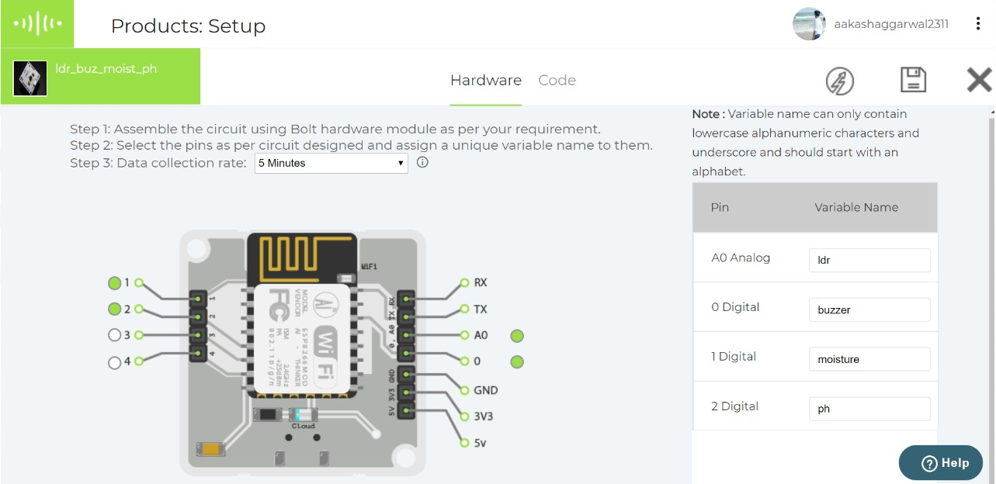

**Specifications of the Bolt Device:**

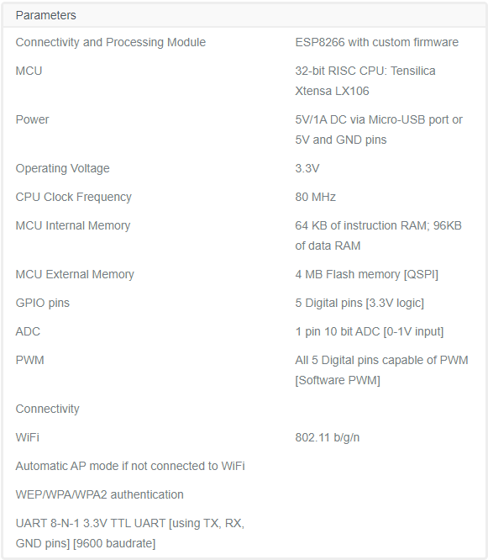

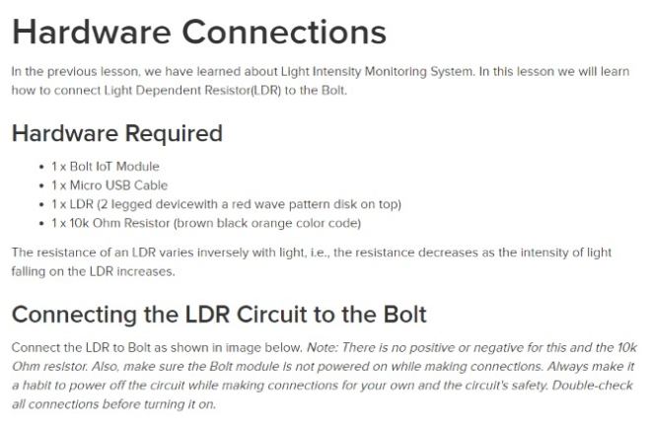

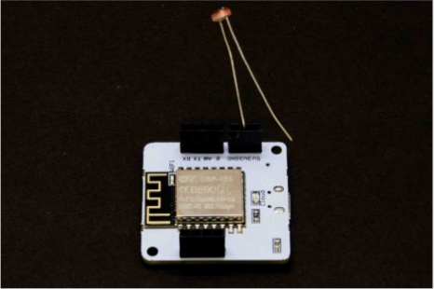

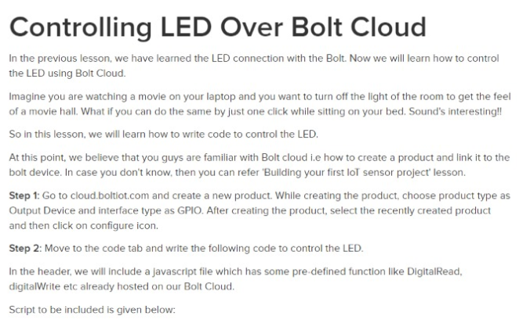

CODE

JAVA SCRIPT

<!DOCTYPE html>

<html>

<head>

<title>Bolt IoT Platform</title>

<script type="text/javascript" src="https://cloud.boltiot.com/static/js/boltCommands.js"></script>

<script>

setKey('{{ApiKey}}','{{Name}}');

var last_pwm_value=-1;

function updateLedIntensity(){

var pwm_value=document.getElementById('pwm_value').value;

if(last_pwm_value!=pwm_value){

analogWrite(0,pwm_value);

document.getElementById('pwm_value_display').innerHTML=pwm_value;

}

last_pwm_value=pwm_value;

}

setInterval(updateLedIntensity,1000);

</script>

</head>

<body>

pwm value:

<input type='range' id='pwm_value' min="0" max="255" value="0">

<div id='pwm_value_display'>0</div>

</body>

</html>

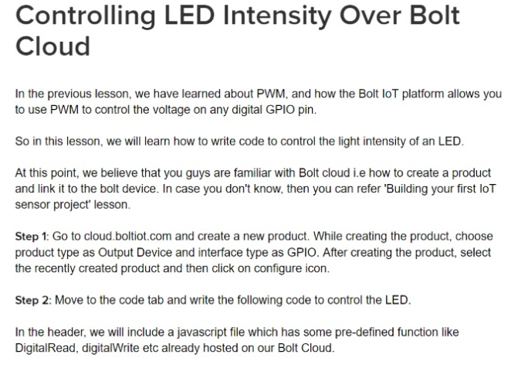

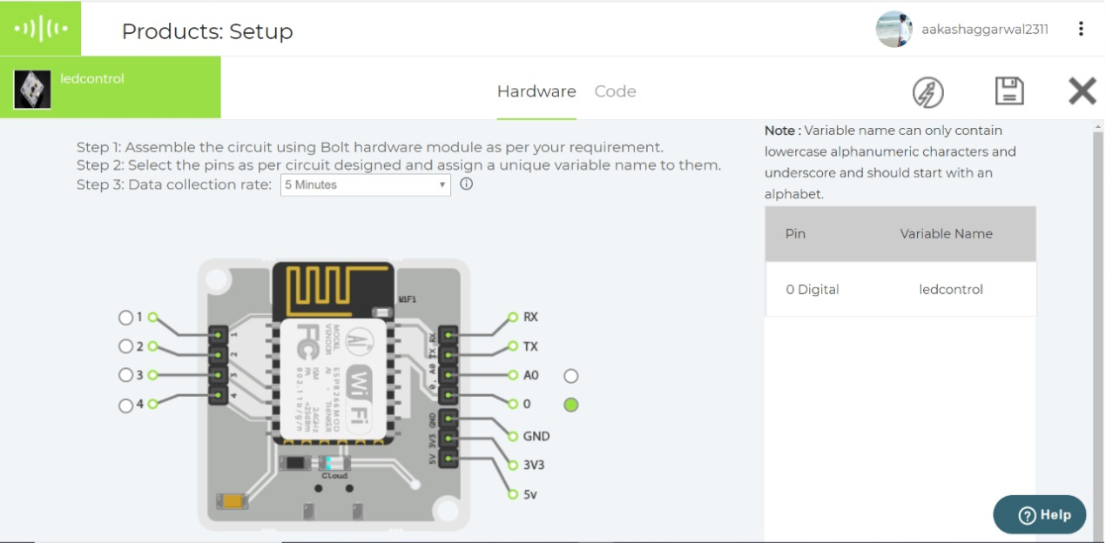

<!DOCTYPE html>

<html>

<head>

<title>Bolt IoT Platform</title>

<script type="text/javascript" src="https://cloud.boltiot.com/static/js/boltCommands.js"></script>

<script>

setKey('{{ApiKey}}','{{Name}}');

</script>

</head>

<body>

<center>

<button onclick="digitalWrite(0, 'HIGH');">ON</button>

<button onclick="digitalWrite(0, 'LOW');">OFF</button>

</center>

</body

</html>

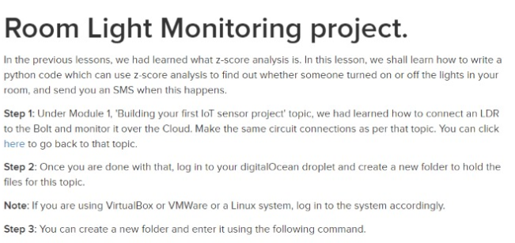

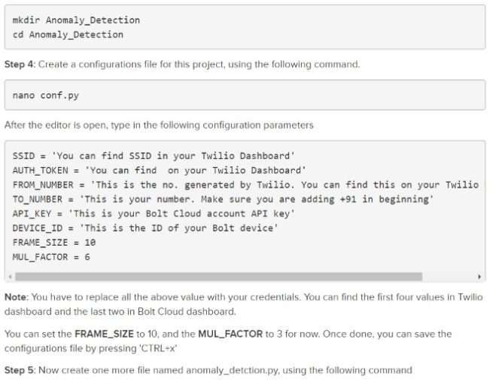

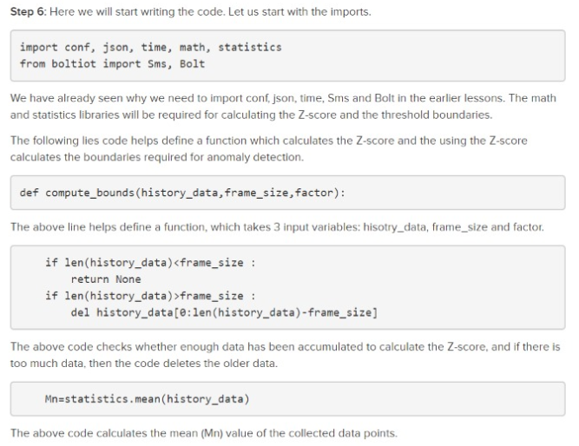

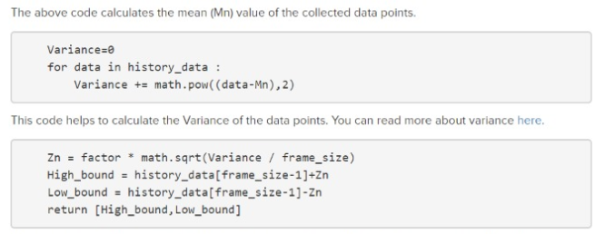

**OUTPUT**

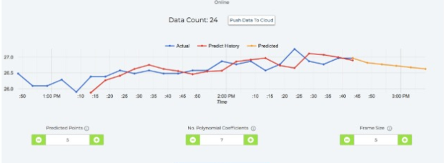

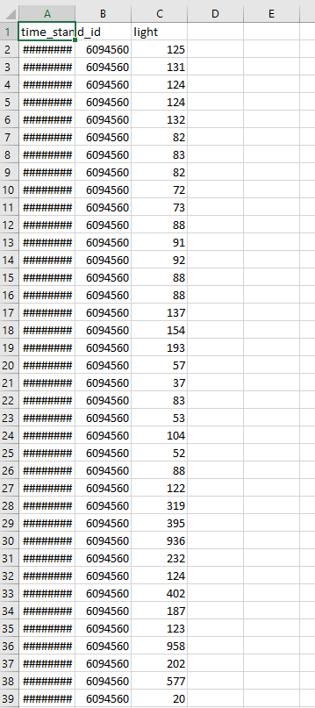

MAIN CODE  
JAVA SCRIPT

<html>

<head>

<title>Bolt IoT Platform</title>

<script type="text/javascript" src="https://cloud.boltiot.com/static/js/boltCommands.js"></script>

<script>

setKey('{{ApiKey}}','{{Name}}');

var last_pwm_value=-1;

/ *start typing your code here */

setChartLibrary('google-chart');

setChartType('lineGraph');

plotChart("time_stamp","light");

if(light>300)

{

digitalWrite(buzzer, HIGH);

}

function updateLedIntensity(){

var pwm_value=document.getElementById('pwm_value').value;

if(last_pwm_value!=pwm_value){

analogWrite(0,pwm_value);

document.getElementById('pwm_value_display').innerHTML=pwm_value;

}

last_pwm_value=pwm_value;

}

setInterval(updateLedIntensity,1000);

</script>

</head>

<body>

pwm value:

<input type='range' id='pwm_value' min="0" max="255" value="0">

<div id='pwm_value_display'>0</div>

</body>

</html>